**Assignment #1 – ADME and rates**

**Due: Thursday 2018-02-08, 11:59pm Enter answers in this document  
Submit solution as a PDF**

* Use this document to insert your solutions, then convert to PDF and submit. Expand the space between each question as needed to incorporate your solution.

* Fonts: use Arial 12 for text.

* If you draw or handwrite parts of this assignment (e.g. equations), you can scan it in using your phone (or similar). Make sure that any solution is clear and readable! I strongly suggest learning to use Equation Editor, MathType or similar to enter equations.

**Name: Hui Shi**

**Question 1 (60 points):** Read chapter 1 of Rosenbaum and chapter 1 of Jambhekar (both chapters are posted on Blackboard). Jambhekar has a good description of ADME and rates. Rosenbaum has a good description of the distinction between PD and PK. Chapter 3 of Jambhekar (also posted) has some good discussion of the different components of modeling pharmacokinetics, such as volume of distribution and clearance rate constants. Chapter 3 also gets a little more into the math of a one-compartment model, more than we will need for this course but it may be helpful for you in developing your ‘PK intuition’.

*In your own words, answer the questions below. For each, a few sentences will be sufficient.*

**1a. Define the therapeutic window of a drug and explain why a narrow therapeutic window makes a drug less likely to make it to market (i.e. less likely to be approved).**

The therapeutic window of a drug refers to the concentration when the drug is effective. Mathematically, it is the concentration range bounded by the lower minimum effective concentration (MEC) and an upper maximum tolerated concentration (MTC). In reality, we want the drug to have an effect on the patients while not being toxic to harm them. The reason that a drug with a narrow therapeutic window is difficult to make it to the market is that the drug needs to be provide consistent bioavailability at a desirable rate, otherwise it could cause toxic or sub-therapeutic concentration which makes it harmful or less effective on the individual. Maintaining the consistency is difficult, and the patients might need supervision from medical professionals, and dosing schedule will need to be precise and more personalized towards the individual's dosing regimen. These limitations are restraining towards its marketability.

**1b. Rosenbaum Table 1.1 gives examples of dose size and dose frequency for different drugs. Jambhekar Table 3.1 gives examples of elimination half lives for different drugs. Complete the following table:**

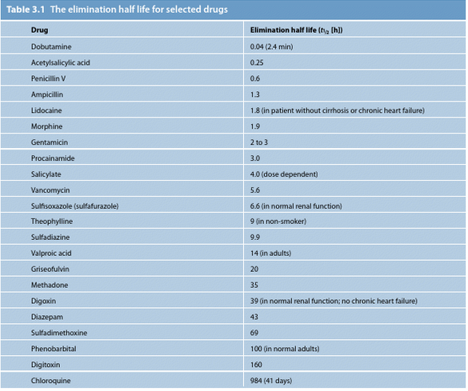

**- Jambhekar Table 3.1**

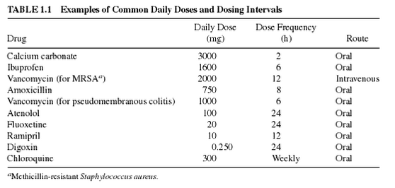

**- Rosenbaum Table 1.1**

|  |  |  |
| --- | --- | --- |
| **Drug** | **Dose Frequency (hrs) - Page 2** | **Elimination half life (hrs) - Page 39** |
| **Vancomycin** | 12  *- Rosenbaum Table 1.1* | 6  *Half-life in normal renal patients is approximately 6 hours (range 4 to 11 hours). In anephric patients, the average half-life of elimination is 7.5 days* [Reference Link](https://www.drugbank.ca/drugs/DB00512#fda-reference) |
| **Acetaminophen** | 8 [Reference Link](https://s3-us-west-2.amazonaws.com/drugbank/fda_labels/DB00316.pdf?1265922805) | 1 - 4[Reference Link](https://www.drugbank.ca/drugs/DB00316) |
| **Chloroquine** | 168 | 984 |
| **Trastuzumab (Herceptin)** | 168 (a week)  *The recommended initial loading dose is 4 mg/kg. Trastuzumab administered as a 90-minute infusion. The recommended weekly maintenance dose is 2mg/kg. Trastuzumab and can be administered as a 30-minute infusion if the initial loading dose was well tolerated. HERCEPTIN may be administered in an outpatient setting.* [Reference Link](https://s3-us-west-2.amazonaws.com/drugbank/fda_labels/DB00072.pdf?1265922812) | 684  *average 28.5 days. Pharmacokinetics are nonlinear; increased doses are associated with increased mean half-life and decreased clearance.*[*Reference Link*](https://www.drugbank.ca/drugs/DB00072) |

**Where can you get the data? The FDA mandates that this data be available on the label of a drug. You may be familiar with the labels of drugs that are printed on the bottle; there’s actually a longer and more detailed label available online at** [**http://www.accessdata.fda.gov/scripts/cder/daf/**](http://www.accessdata.fda.gov/scripts/cder/daf/)**. A simpler place to start, though, is** [**https://www.drugbank.ca**](https://www.drugbank.ca) **which maintains a simpler data page for each drug. For example, type vancomycin into the FDA site and you’ll get several results including some discontinued drug formulations. The full label information is there for some of these and not others. In the long-form label (for vancomycin, a 13-page PDF!) dosing is in section 2 and pharmacokinetics in section 12.3. Truthfully, the FDA site is best for more recent drugs. For most drugs the better place to start is the Canadian site. Type vancomycin into it and then scroll down to the pharmacology to find half-life information. Finding the dose scheduling is a little trickier; in the ‘References’ section, you will find links to the FDA label and to drugs.com, both of which will give dose and dose frequency information.**

**1c. Once you’ve completed the table in 1b, explain why the difference in elimination half-lives between the drugs in the table above leads to the difference in dose scheduling between these drugs.**

With a longer half-life, the drug needs to be dosed less frequently since the drug can stay in the system longer. The drug which gets eliminate faster will need supplement to continue the dosing to maintain the drug effects. That is why the drug with a shorter elimination half-life needs to have a more frequent dosage to maintain effective. In contrast, if a drug with a longer elimination half-life gets a more frequent dosage, the drug might not be eliminated quickly enough and reach a toxic concentration that is harmful to the patient.

**1d. In Rosenbaum (and many places), the ‘E’ in ADME stands for Excretion, while ‘Elimination’ is a term including both Metabolism and Excretion (*see* Rosenbaum Fig 1.8). Defining metabolism as completely part of elimination misses the point that not all metabolism eliminates the drug from the system (*see* Jambhekar** **Fig 1.5). Explain why metabolism (enzymatic processing) of the molecules delivered to the body does not *necessarily* deplete the effect of the drug.**

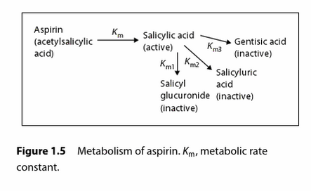

Metabolism is the process of converting one chemical species into another chemical species through the acceleration of this transformation process with the enzyme. The metabolism transforms the active form of the drug to another chemical species which is usually ineffective. However, there are causes such as the one illustrated in Jambhekar Fig 1.5 when the species after transformation still stays as an active ingredient with the same effect or possibly more effective than its precedent species of the drug. In cases such as this one, the enzymatic processing of the molecules delivered to the body does not necessarily deplete the effect of the drug.

**1e. Define the** **volume of distribution of a drug, and explain why the volume of distribution of a drug can be larger than the volume of the person taking the drug (*see* Jambhekar Fig 3.9).**

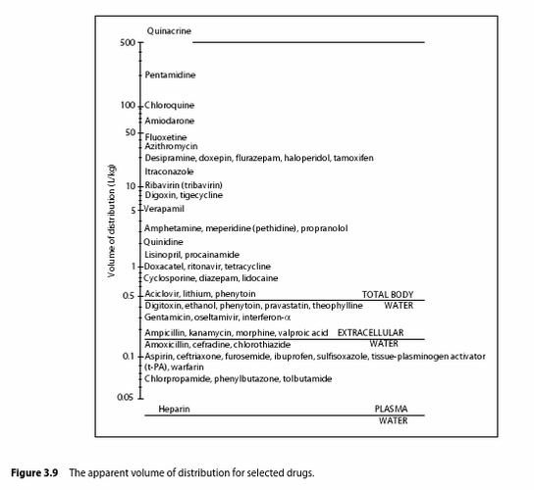

The volume of distribution is the apparent volume to dilute a given mass of drug into the observed concentration. The reason may be resulted from highly lipophilic nature of the drug. The more lipophilic the drug is, the greater is the apparent volume of distribution. On the other hand, if the drug is hydrophilic, the drug will be restricted into a certain area of the tissue and causes the plasma concentration to be higher and its volume of distribution smaller. Therefore, it is possible that a drug is very lipophilic and is able to penetrate into the tissue more, resulting in a very high apparent volume of the drug distribution that can be even higher than the volume of the person taking the drug.

**Question 2 (40 points):** In reference to the attached paper by Paul et al (“How to improve R&D productivity: the pharmaceutical industry’s grand challenge”), answer the following questions.

**2a. The paper defines the ‘pharmaceutical value equation’ as follows**

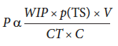

**list and describe each of the components on the right hand side of this equation, and why they appear above the line or below the line in the fraction.**

**WIP - work in progress, representing the total amount of research conducted.**

The work in progress can increases the R&D productivity.

**p(TS) - probability of technical success, representing the success rate of the research conducted**

The more likely the effort is going to be successful, the more work in progress can contribute to the R&D productivity.

**V - value, the value of the research conducted**

If the product is the more valuable, it is more productive.

Overall, it makes sense that the more valuable, the more likely to be successful, and the greater amount of the research is done, the more productive the R&D process is.

**CT - cycle time, the duration of the research project**

The longer to design and manufacture the drug, the less efficient the R&D productivity is. Since it impedes the productivity, it is on the denominator

**C - cost**

The more expensive the drug development process is, the less efficient the R&D productivity is.

Overall, it makes sense that the more time needed for the project, the larger cost the product is, the less productive is the R&D process.

**2b. In Figure 2, the authors use the values of these parameters, for each stage of the process, to define the overall cost of a new molecular entity ($1.778 billion when including the cost of capital, $873 million outright). Why do the costs escalate as we go from phase 1 to 2 to 3 of the clinical trial cycle, even though the number of drugs being tested goes from 8.6 to 4.6 to 1.6?**

Despite the number of drugs being tested goes down, the test is more complicated as the phase goes up. Stage 1 is the safety test, stage 2 is the efficacy test, and stage 3 is the large-scale efficacy test. Stage 1, being the smallest test, only requires to show that the drug does not harm people. Stage 2 is more rigorous and large-scaled and needs to prove the drug's efficacy. Stage 3 gets into a large scale clinical studies involved a lot of people across different populations. As each study gets larger and more complicated, they will need to cost more to be conducted.

**2c. Explain why ‘fast failure’ is hypothesized to be helpful in improving success rates of drug development.**

The fast failure refers to an earlier failure in the drug development process. Using the 'fast failure' paradigm, the pharmaceutical company reduces its cost in the later expensive developmental stage by intervening the development of the ineffective drug with the proof-of-concept (POC). By doing so, the company increases its probability of technical success and decrease the cost of the drug development, therefore increasing the R&D productivity. Those saving gained from the late-stage R&D failures can be re-invested in R&D and enhance the R&D productivity.